**DWDM**

**Model Practical lab**

18BCS010

R.

1) Choose a Dataset for association from any Respostory list the attribute and kept in word doc.

2) Download “pima-indians-diabetes.csv” dataset. Load thedataset and implement Naïve Bayes Classification algorithm using python. Divide the dataset to Training set and testing set. Calculate probabilities and build prediction model. Print the Prediction for Test set and accuracy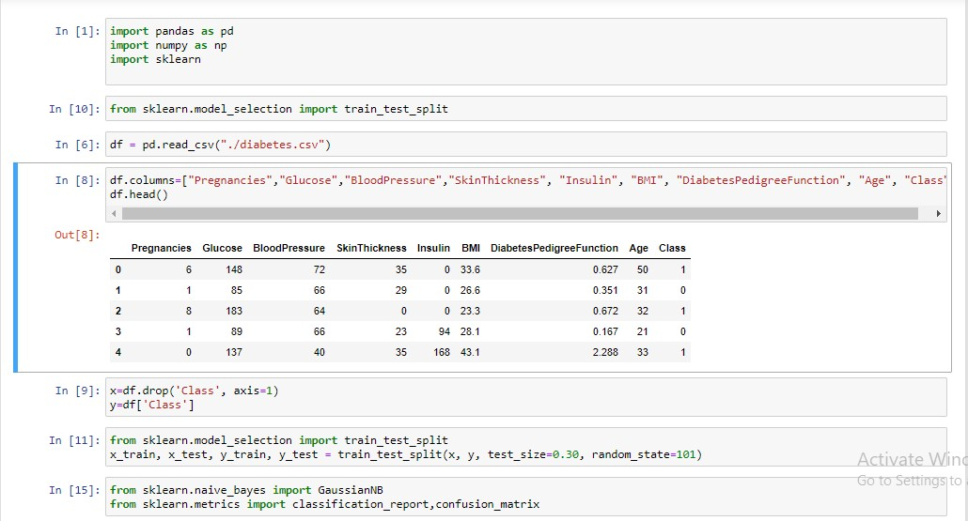

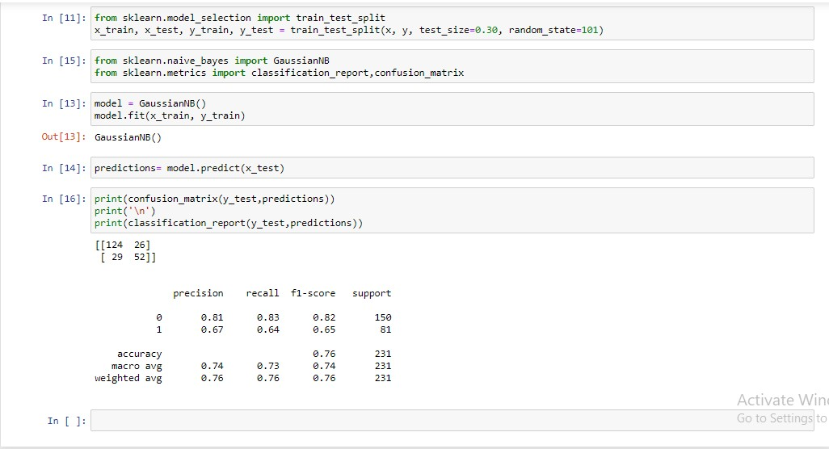

3) github link:

https://github.com/sharankumarbalaji/diabetes.git

4)